Upliance.ai Assignment - Pranav Mohan

According to the data provided, Spaghetti and Grilled Chicken are the most popular dishes.

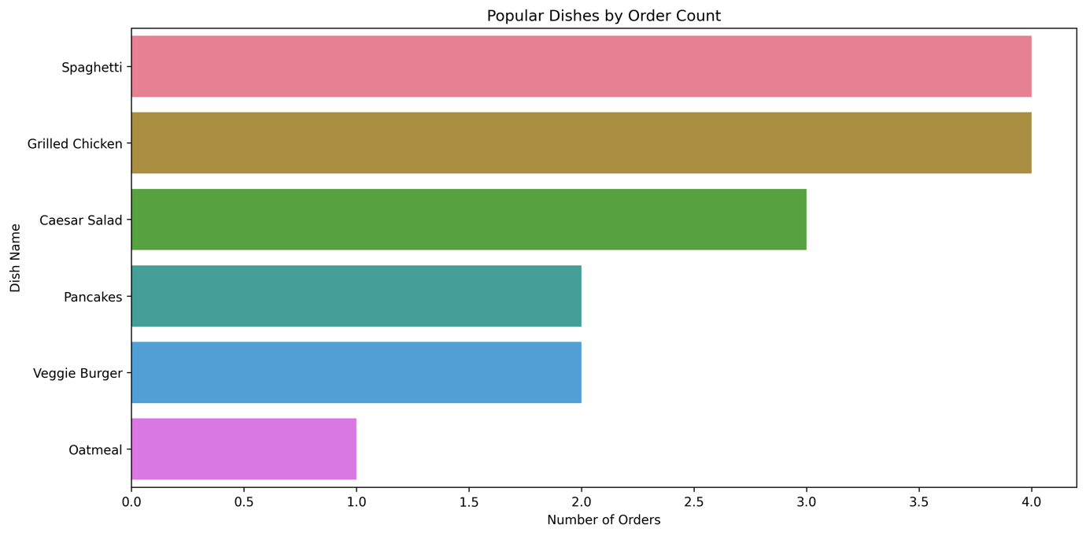

Grilled Chicken has the highest average order rating of 4.67. It is also the dish that has the longest preparation time on average.

|  |  |  |  |  |
| --- | --- | --- | --- | --- |
| Dish Name | Avg Order Rating | Avg Session Duration (mins) | Avg Customer Age | Total Orders |
| Grilled Chicken | 4.67 | 42.5 | 31.2 | 4 |
| Spaghetti | 4.50 | 35 | 32 | 4 |
| Caesar Salad | 4 | 21.7 | 30.7 | 3 |
| Pancakes | 4 | 30 | 35 | 2 |
| Veggie Burger | 4 | 20 | 36.5 | 2 |
| Oatmeal | 4 | 10 | 35 | 1 |

It is also important to notice that the dishes are not being made for different meals. Spaghetti and Grilled Chicken are made during dinner time only. While Caesar Salad and Veggie Burgers are made during lunch time.

The reason behind this could probably be associated with the user demographics. The average age of the user is 31.8 years which means that the average user is working professional.

-It is easier for working professionals to find time after working hours therefore, 50% of the users order at dinner time.

-Caesar Salad and Veggie Burger require less time to be prepared. That is why they are only ordered during the lunch timings.

-Spaghetti and Grilled Chicken require a lot of time to be prepared which explains the orders during dinner time only.

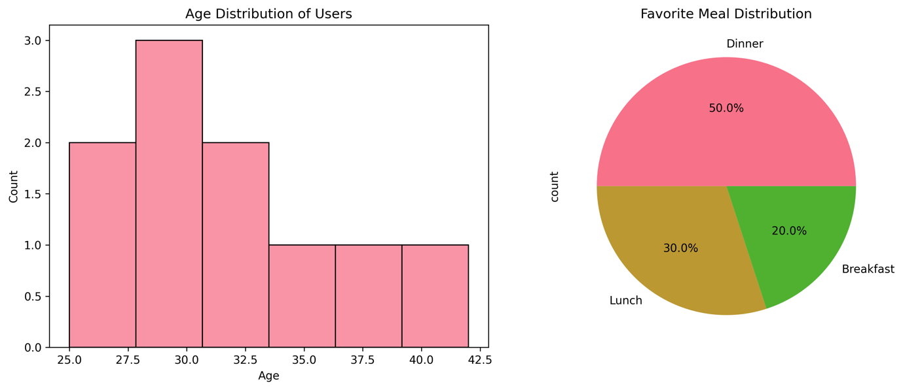

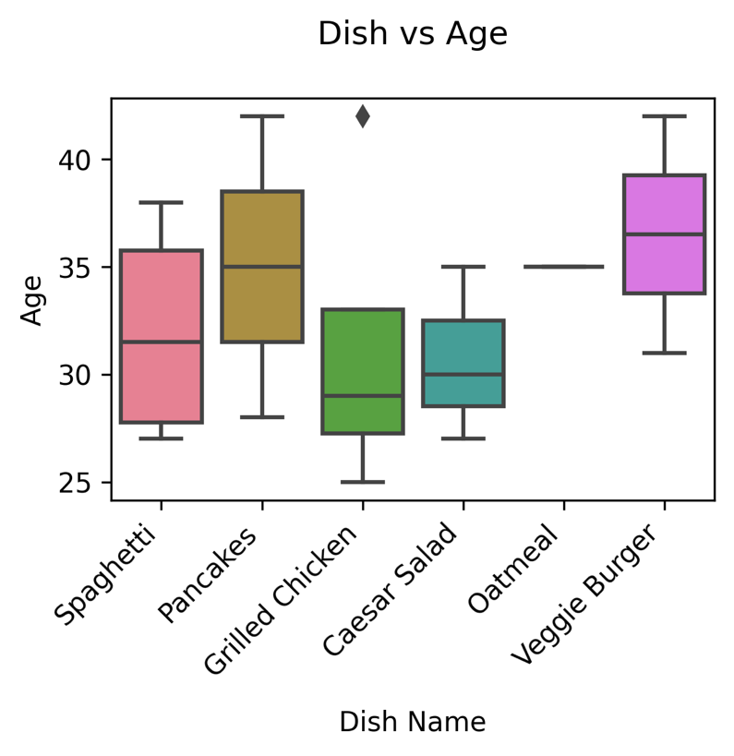

Relationship between cooking sessions and user orders:

-Users tend to enjoy the process of making meals that have a longer preparation time like Grilled Chicken and Spaghetti (they have the highest average session rating).

-Quick meals yield poor results in terms of experience.

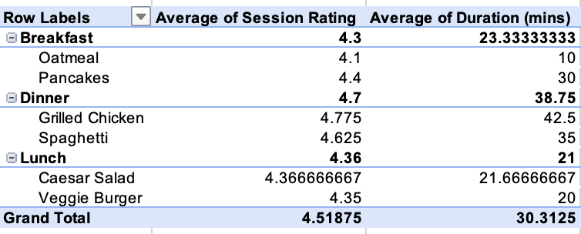

Business Recommendations:

1. Given that the average user is in their 30s, the marketing can be optimized by:

* Focusing on the fact that it is less time consuming to use upliance than to cook from scratch on their own.
* Promoting healthier food options.

1. Improve recipes that have a short preparation time as they have lower ratings.
2. Recipes like Grilled Chicken and Spaghetti should be added to the menu as they are the most ordered as well as the highest rated orders.

-Submitted by Pranav Mohan